GTO Technology Supply

Testing and Transformation Services

Platform Custom Automation

**Authors**

Eric Amundson

Reedy Feggins

**Contributors**

Suraj Rajendran

Control-M

Version 0.1



Table 1 Control Table

|  |  |
| --- | --- |
| **Document Approver(s)** | Jeff Wakefield, Ramanathan Kalyanasundaram, Suraj Rajendran |
| **Document Owner(s)** | Eric Amundson, Reedy Feggins |

Table 2 - Revision History

|  |  |  |  |
| --- | --- | --- | --- |
| **Date** | **Version** | **Details** | **Updated By** |
| 03/25/14 | 0.1 | Updated Document with expected deliverables. | Eric Amundson |
|  |  |  |  |
|  |  |  |  |
|  |  |  |  |

Table 3 – Sign-off History

|  |  |  |  |
| --- | --- | --- | --- |
| **Date** | **Reviewed By** | **Version** | **Next Sign-off date** |
| 03/02/2014 | <AS Stakeholder Name> | 1.0 | <Next Sign-off Date> |
|  |  |  |  |

**Table of Contents**

1. About This Document 4

1.1. Document Purpose 4

1.2. Document Stake Holders 4

1.3. Document Scope 4

1.4. Key Requirements 4

1.5. Procedural Responsibility 4

1.6. DAP Integration plugin – Plugin Operational Steps 4

2. UrbanCode Plugins Overview 5

3. DAP Integration Plugin - Use Cases 6

3.1. Use Case 1 - Web archive (WAR) file deployment 6

3.1.1. Application Properties 6

3.1.2. Resource Properties: 6

3.1.3. Recommended Environment Property 6

3.2. Use Case 2 - Enterprise archive (EAR) file deployment 7

3.2.1. Required Application Properties 7

3.2.2. Resource Properties: 7

3.2.3. Environment Property 7

3.3. Use Case 3 - Standard Java Archive (JAR) file deployment 7

3.3.1. Application Property: 7

3.3.2. Resource Properties 7

3.3.3. Environment Property 8

3.4. Use Case 4 - Platform-Config File deployment 8

3.4.1. Application Property: 8

3.4.2. Resource Properties 8

3.4.3. Environment Property 8

4. Use Case 1 – WAR File Deployment - Step by step screenshots 8

4.1. Steps to Modify Resources and Agents 8

4.2. Steps to verify Resources and Properties 11

4.3. Post-Deployment Verification Steps 13

5. Appendix 13

5.1. Document Location 13

5.2. Glossary 13

5.3. Reference Documents 14

# About This Document

## Document Purpose

This document provides the use cases and technical design for the custom plugins used to integrate IBM UrbanCode Deploy with BMC Control-M. BMC Control-M provides applications the ability to schedule large and complex jobs.

This **KOP** document will also serve as a template for developers when they create deployment instructions for a software delivery using Control-M with UrbanCode Deploy.

This document should be used in conjunction with the GTO Technology Supply Integration Release & Deployment Operations Policy and Standards document.

## Document Stake Holders

* PM - Deployment Operations Team
* PM – Production Release Implementation Team
* PM - Change Management Team
* Application Services Team
* PM – L2 Support Team
* PM - Test Environment Services Team
* OS/Networks/Storage Provisioning Teams (Unix Ops / DBA Ops / IBM)

## Document Scope

This document covers all application within the GT organization across all regions including all controlled Test and Production Environments.

## Key Requirements

This document assumes that the reader has a working knowledge of the Deployment, Release and Change Management Processes.

## Procedural Responsibility

It is the responsibility of the in-scope Deutsche Bank staff assigned to undertake or follow the procedures within this document to ensure they are, and remain, fully aware, understanding and conversant with the content of this Standard Operating Procedure as a pre-requisite to undertaking the delivery of the related services.

It is the responsibility of the target audience / in-scope Deutsche Bank staff to escalate to their line manager and, subsequently, where necessary, the owner of this document, any errors, identified weaknesses or perceived omissions to this Standard Operating Procedure document

## Control-M Integration plugins – Plugin Operational Steps

The integration between Control-M and UCDeploy will be limited to the following Control-M operational step for automating import to Control-M

* Control-M Update Definition

The Control-M plugin with us custom scripts to execute a step that will update a complete Control-M’s folder definition.

There will also be an integration to manage versions of a Control-M component created by DB personel. This component is in the form of a zip file that contains a set of xml files with the data to be imported into Control-M. This ‘source’ plugin will scan a directory for changes in zip files related to specific application and added the files as versions into uDeploy repostitory.

# UrbanCode Plugins Overview

Within IBM UrbanCode Deploy, plug-ins provide two basic capabilitie:

* Tools for accelerating the creation of component processes.
* integrate many third-party tools into IBM UrbanCode Deploy, such as application servers and software configuration management products.

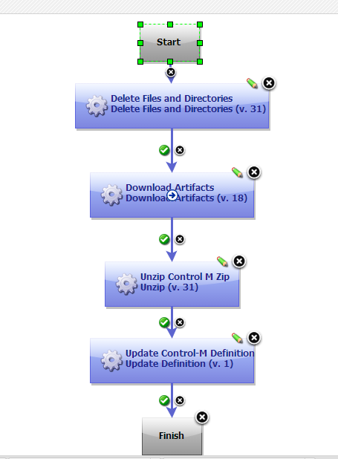

Each Plug-in consists of configurable steps, which can be thought of as distinct pieces of automation that can be combined with other steps in the IBM UrbanCode Deploy editor, to create fully automated deployment processes.

For example, the screenshot above captures one of the primary works for the Control-M Integration plugin. This workflow provides the steps to ensure Control-M is updated with changes to specific Control-M folder.

In general a plug-in consists of a number of steps. These steps vary from plug-in to plug-in. Each step consists of a number of properties, a command that runs the step, and post-processing instructions (typically used to ensure that expected results occurred). Step properties can serve a wide variety of purposes, from providing information to the command, to supplying some or all of the actual command itself. Then, a second component process is used to stop, update, and start the application.

# Control-M Integration Plugin - Use Cases

For each of the following use cases, the Template Reference implementation will

* Abstract each Control-M contextual environment into a set of UCD Resources
* The Componet template assumes that deploy artifacts (ZIP files) will first be deployed to the lowest DAP environment (Staging server)
* The Component process will initiate calls to the Control-M to promote the deploy artificats to Production Server.

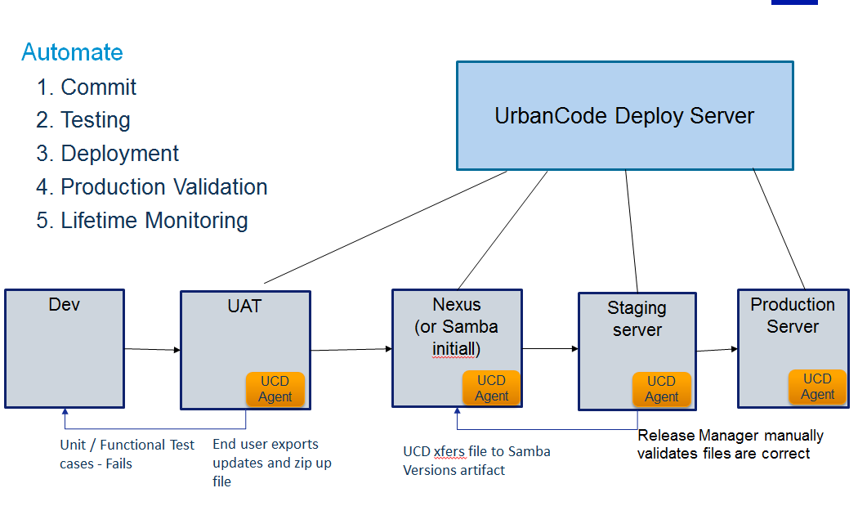

## Use Case – Update Control-M Definition

* The Deployer will have bundled up a set of xml files that contain Control-M job definitions into a zip file.
* This zip files will be placed onto a filesystem that a uDeploy agent will scan for updates or new files.
* The Control-M source plugin will pick up these changed files and create new versions related to a uDeploy component that matches a property for the ‘narid’ in the zip file.
* Deployer will activate a application process to deploy Control-M job definitions for a specific environtmen (STAGING, PROD).

Note! There will need to be a uDeploy component created per Control-M ‘narid’.

# Use Case - Step by step instructions

## Steps to ensure proper configuration

1. Login to IBM UrbanCode Deploy
2. Verify plugin is available by selecting Settings --> Plugins --> Automation Plugins --> DB Control-M

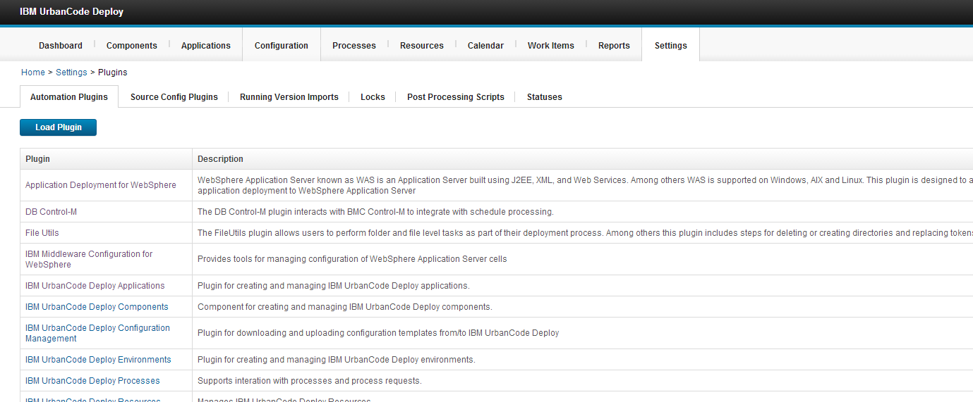

1. Verify the Source Plugin by selecting 🡪 Settings --> Plugins --> Source Config Plugins --> ControlM ZIP File (Versioned)

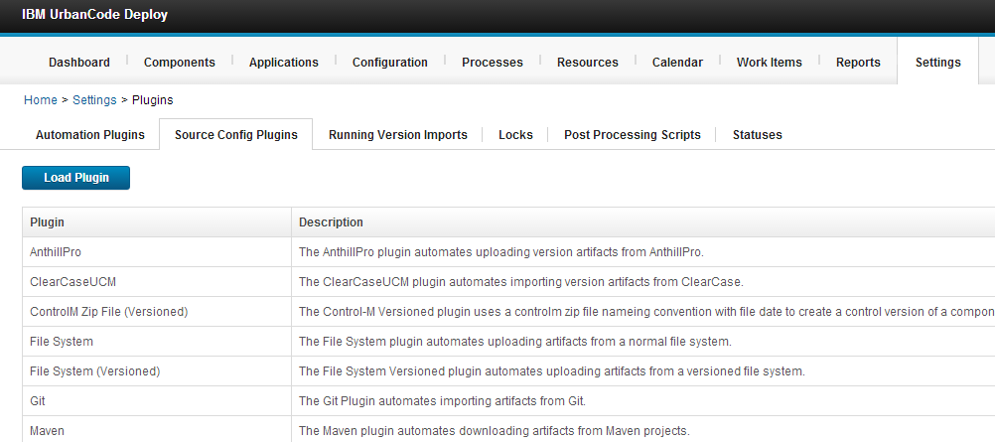

1. Component --> Templates --> DB Control-M

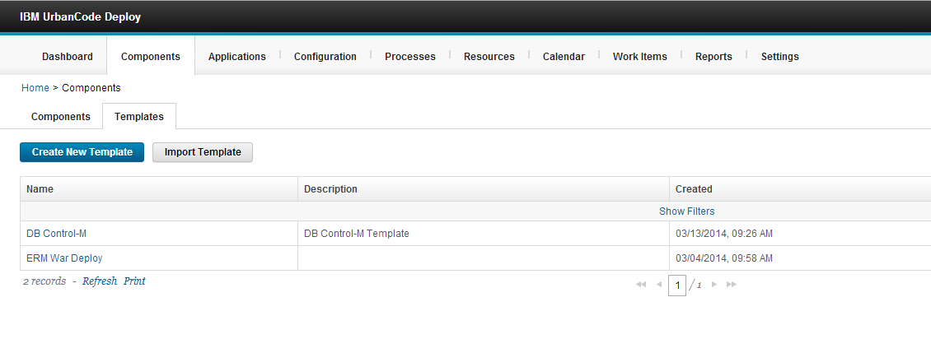

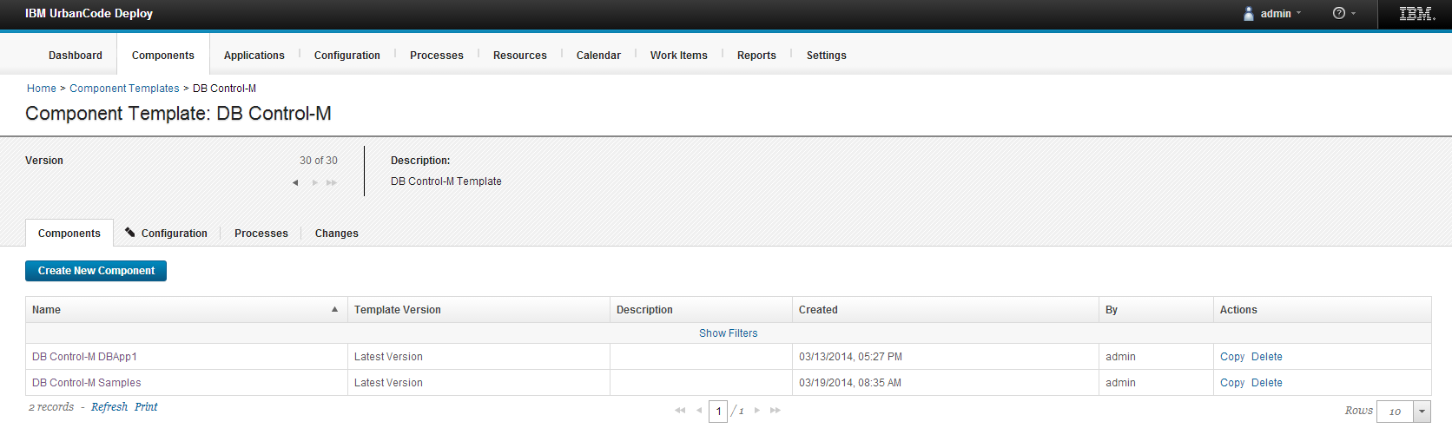

1. View Control-M Process

After a zip versions are added to uDeploy repository, this process will pull a Deployer selected zip version, unzip and import the contained xml files into Control-M

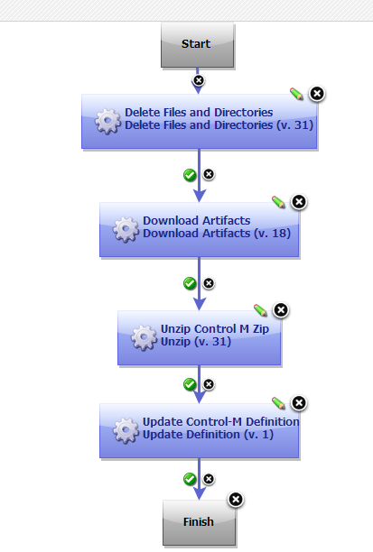

## Steps to setup Control-M application job definitions for uDeploy deployment

Setup of a component to match zip component’s relations to NARID.

1. Create a new Control-M component. Components 🡪 Create New Component

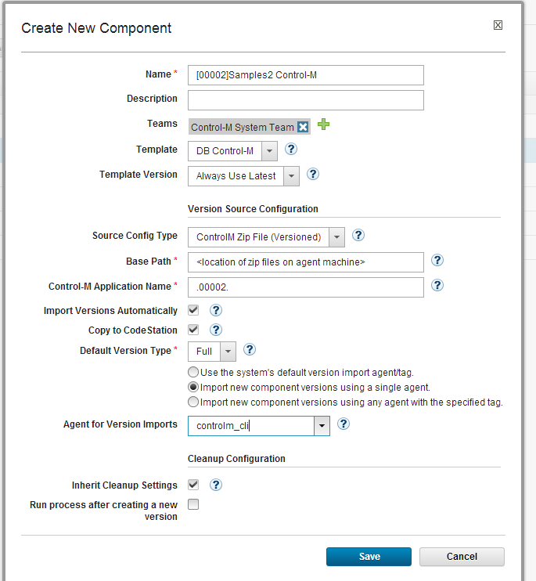

1. Create new application related to NARID. Application 🡪 Create Application.

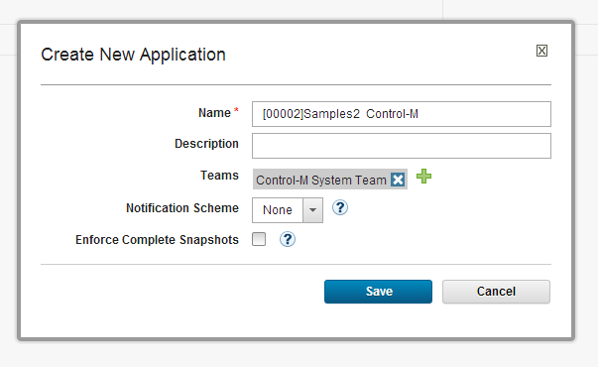

1. Set new application component. Applications 🡪 “[00002]Samples2 Control-M 🡪 Components 🡪Add Component.

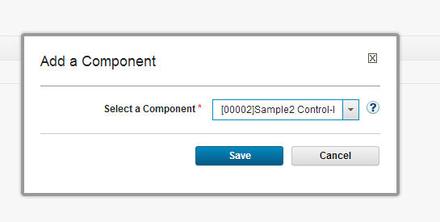

1. Add required environments to application. Applications 🡪 “[00002]Samples2 Control-M 🡪Environments 🡪 Add Environment.

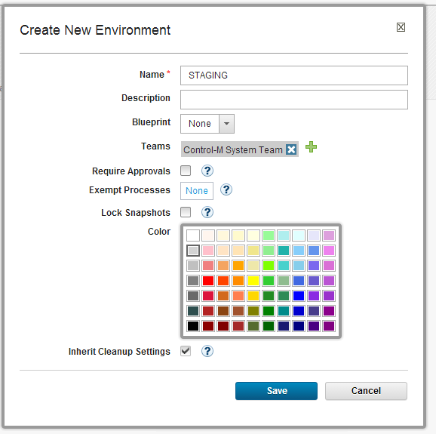

1. After setting environment we need to select a execution resource for environment. Resource 🡪 Add Component to Resource.

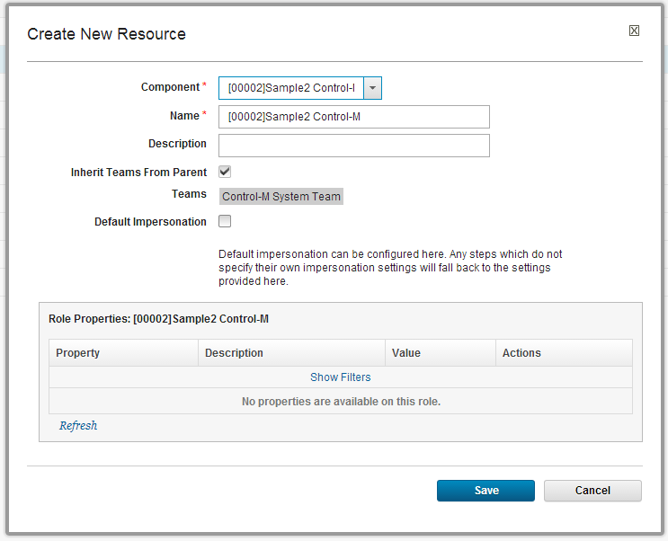

1. Add component to environment. Applications 🡪 [00002]Samples2 Control-M 🡪Environments 🡪 Environment: STAGING 🡪 Add Base Resource.

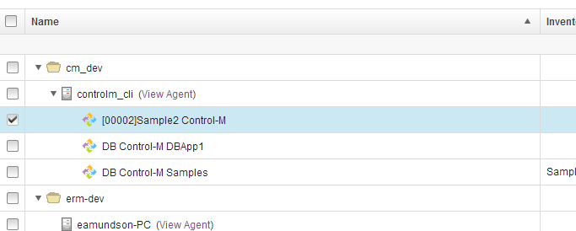

1. Setup application process. Application 🡪Processes 🡪 Create New Process. Then add single setup to design.

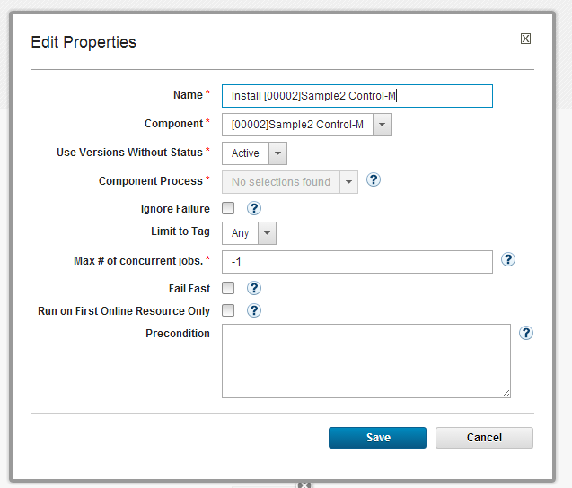

1. Connect node edges.

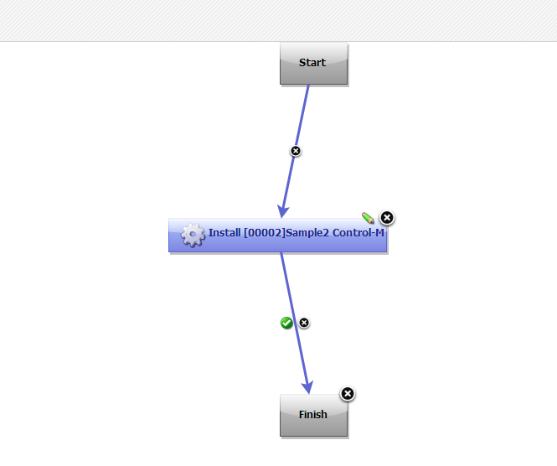

1. Setup environment properties. Application 🡪 [00002]Samples2 Control-M 🡪Environments 🡪Environment: STAGING 🡪 Configuration 🡪 Environment Properties.

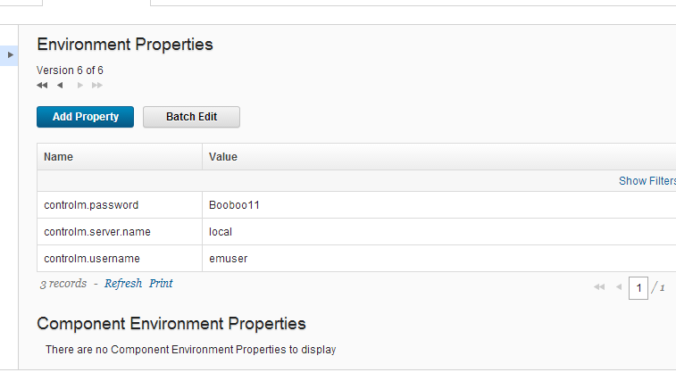

## Post-Setup verification

Also the uDeploy application keeps a log of its activities, including both successful operations and notes about any failures that may occur.

The log files can be found, by default, in the following location

uDeploy configuration should be updated to automatically send out the deployment log files by e-mail to a pre-defined distribution list (support teams) post-deployment (must be sent especially when an application deployment has failed).

# Appendix

## Document Location

Any reference document(s) referred in this document can be accessed through the following link:

<Any reference urls for documents etc can be referred here>

## Glossary

A Glossary of Release and Deployment Management terms and acronyms can be accessed through the following link:

|  |  |
| --- | --- |
| **Acronym / Term** | **Meaning / Description** |
| DB | Deutsche Bank |
| DBA | Database Administrator |
| GT | Global Technology |
| PM | Project Manager |
| SCM | Software Configuration Management |
| OS | Operating System |
| TOM | Target operating model |

## Reference Documents

|  |  |
| --- | --- |
| **Name of Document** | **Description** |
| Deployment Operation prepared | This is a generic GT - Deployment Operations run book for production environment |
| uDeploy user guide | UDeploy product user guide which is published by vendor IBM |